**CREDIT CARD PROCESSING SYSTEM ADVANCED**

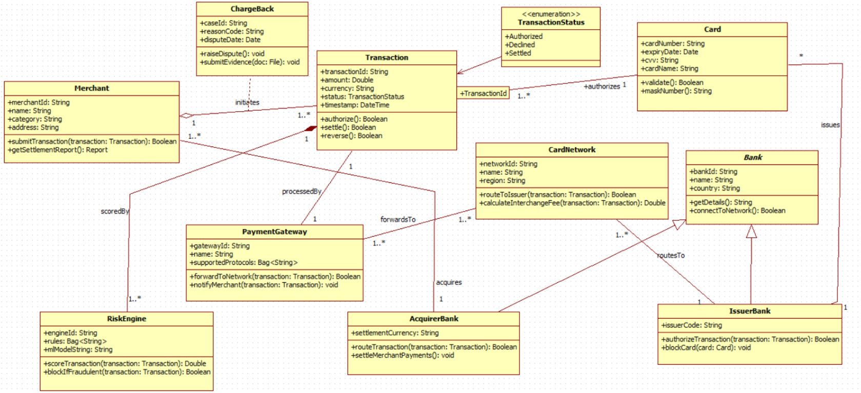

**PASSPORT AUTOMATION SYSTEM ADVANCED**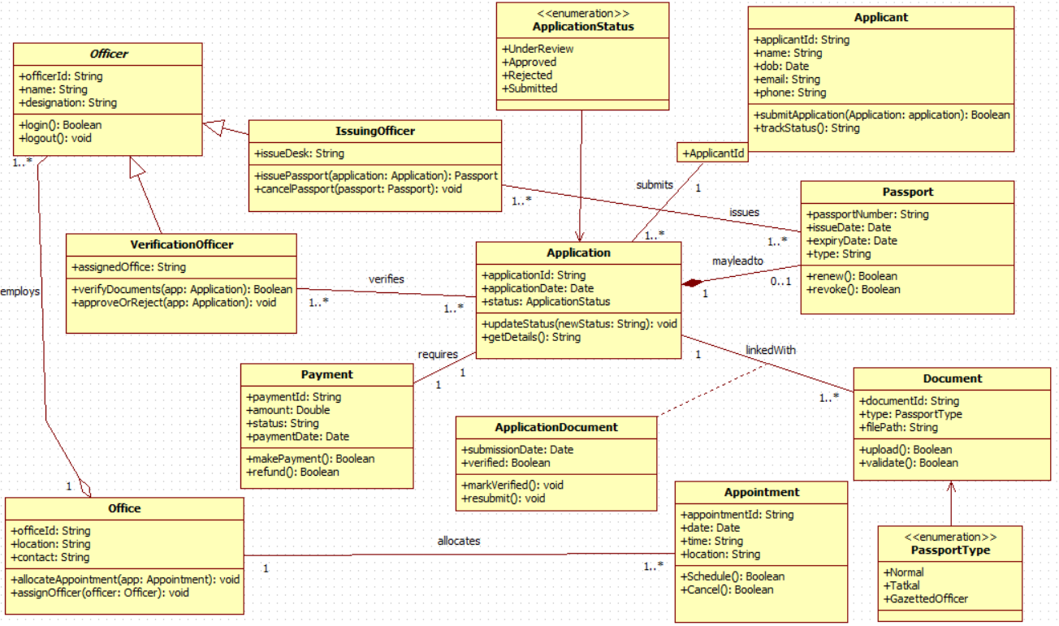

**HOTEL MANAGEMENT SYSTEM ADVANCED**

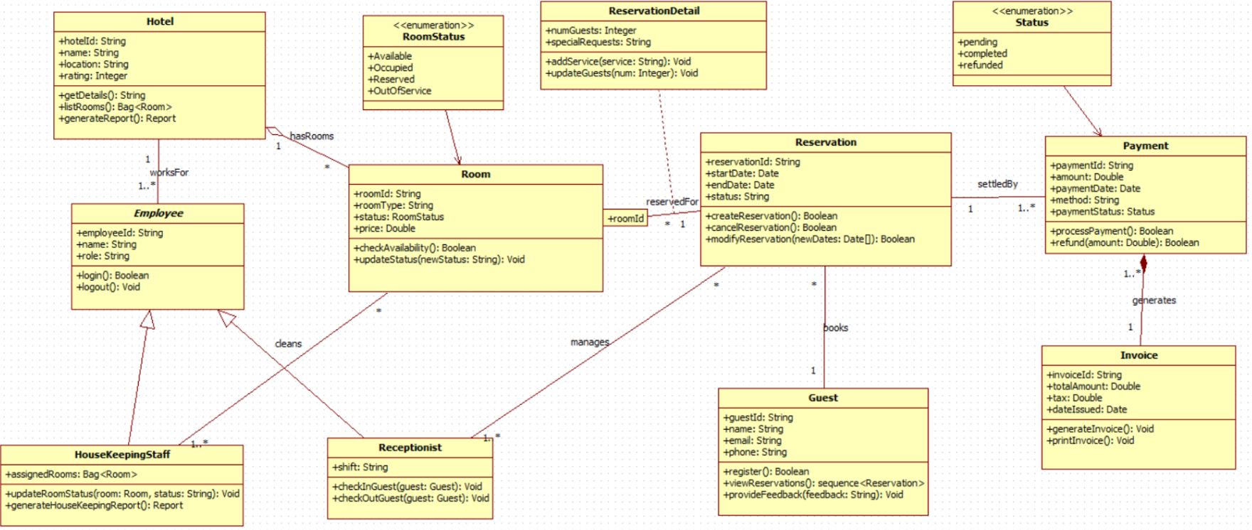

**LIBRARY MANAGEMENT SYSTEM ADV**

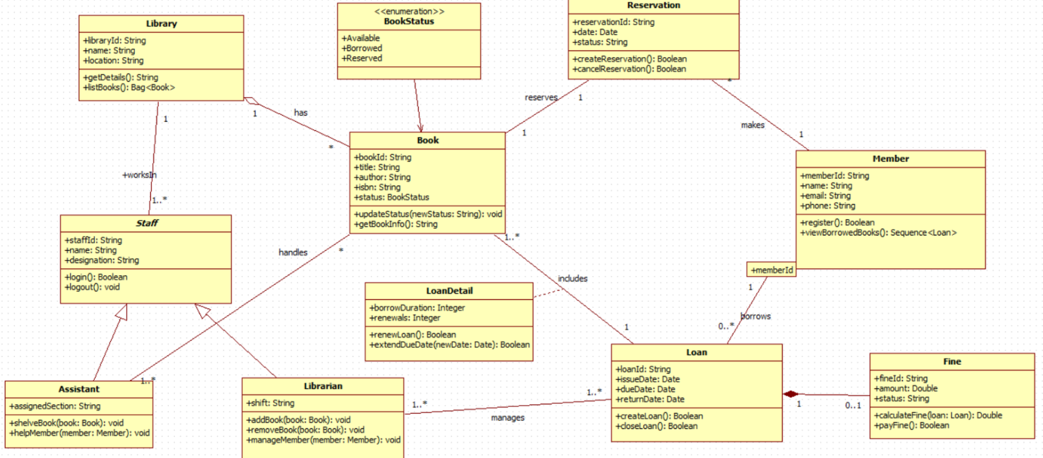

**STOCK MAINTAINANCE SYSTEM ADVANCED**